 **Introduction to DevOps**

**BCS/BS 6A**

Lab: 02

# GROUP MEMBERS:

MUHAMMAD SHAYAN SHAHID (2212325)

MUHAMMAD ASHAD BAIG (2212115)

Task 1: Create a virtual network

In this task, we will create a virtual network.

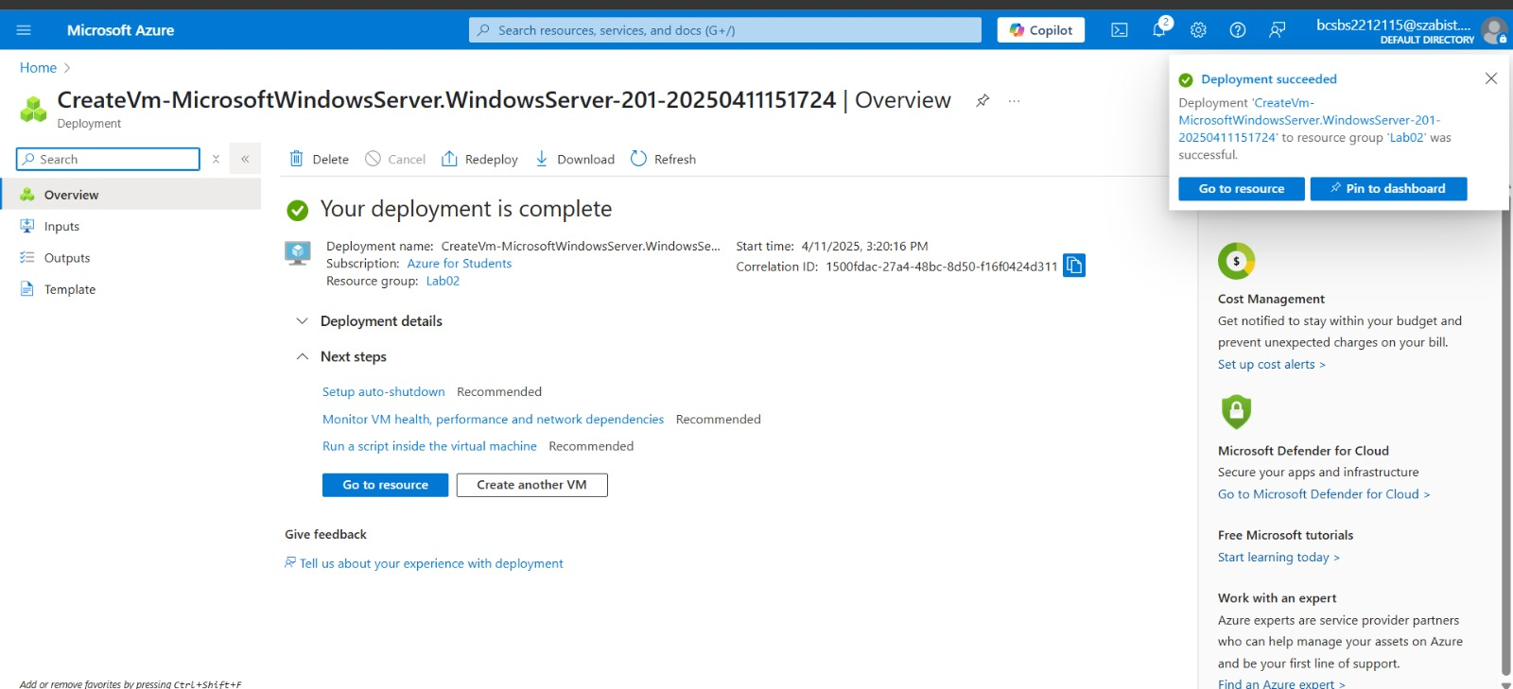

Task 2: Create two virtual machines

In this task, we will create two virtual machines in the virtual network.

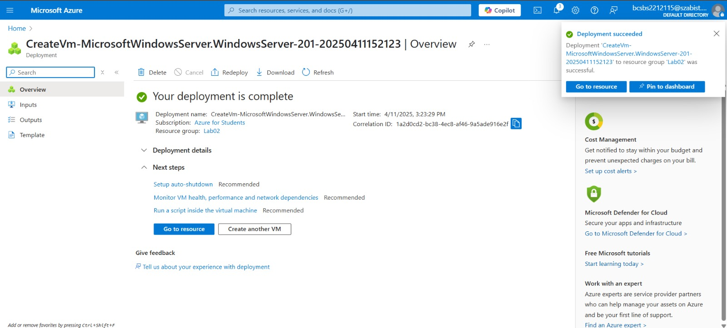

Task 3: Test the connection

In this task, we will try to test whether the virtual machines can communicate (ping) each other. If not we will install a

rule to allow an ICMP connection. Usually ICMP connections are automatically blocked.

